RESOLUTION NO.__________

RE: CERTIFICATE OF APPROPRIATENESS UNDER THE
PROVISIONS OF THE ACT OF THE PENNSYLVANIA
LEGISLATURE 1961, JUNE 13, P.L. 282 (53
SECTION 8004) AND BETHLEHEM ORDINANCE NO.
3952 AS AMENDED.

WHEREAS, it is proposed to install a sign above the storefront at
523 Main St.

NOW, THEREFORE, BE IT RESOLVED by the Council of the City of Bethlehem that a Certificate of Appropriateness is hereby granted for the proposal.

Sponsored by: (s)

(s)

ADOPTED BY COUNCIL THIS DAY OF

(s)
President of Council

ATTEST:

(s)
City Clerk

HISTORICAL & ARCHITECTURAL REVIEW BOARD

The applicant proposes to install a sign above the storefront at
523 Main St.
APPLICATION #1:

Mary Ellen Williams
523 Main St.
Bethlehem, PA 18017

518 Main St.
Bethlehem, PA 18018

OWNER:

__________________________________________________________________________

The Board upon motion by Phil Roeder and seconded by Beth Starbuck adopted the proposal that City Council issue a Certificate of Appropriateness for the following:

- Background of the sign is to be black with a beige (off-white) border.

2. Letters to be pink with beige (off-white) highlights.

3. Size of sign will be 19.2” x 14” in two panels.

4. The motion was unanimously approved.

__________________________________________________________________________

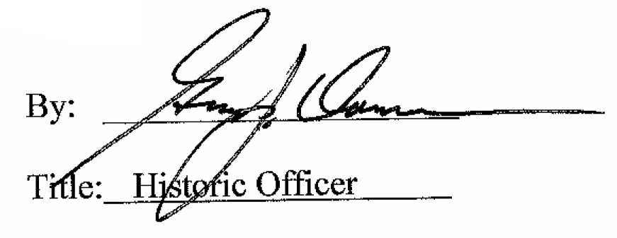

Date of Meeting: February 14, 2018

